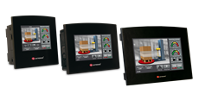

Press Release For Immediate Release

Samba™ - New I/O Configurations Increase
Low-end Application Options

Unitronics has now released four new models of Samba, a cost-effective all-in-one, PLC with HMI and onboard I/Os. A new I/O configuration, TA22, is now available in 3.5", 4.3", and 7" screen sizes.
Models SM35-J-TA22, SM43-J-TA22, and SM70-J-TA22 comprise:
- 12 Digital Inputs, in total. These may function as npn/pnp inputs, or be configured to include:
1 HSC/Shaft-encoder
2 Analog/Digital Inputs
2 Thermocouple / PT100 inputs
- 8 Transistor pnp Outputs (source)
- 2 Analog Outputs, 12-bit
Another new model, SM70-J-RA22, comprises a 7" screen, with the following I/O configuration:
- 12 Digital Inputs, in total. These may function as npn/pnp inputs, or be configured to include:
1 HSC/Shaft-encoder
2 Analog/Digital Inputs
2 Thermocouple / PT100 inputs
- 4 Relay Outputs
- 4 npn Outputs (sink)
- 2 Analog Outputs, 12-bit
A new version of VisiLogic, the programming environment for Samba, has also been released to support the new Samba models. This release offers two additional features:
- Profibus for Vision 700. The V700 can now act as a Profibus slave, joining the V430, V350, and V130.
- List of Meters: New HMI Element:
This enables you to display completely different versions of the same meter by changing an index number.
Unitronics has also released new versions of Remote Access and Remote Operator for PC. These versions support List of Meters, and are available for download from the Unitronics web site.

About Samba
Samba fills a growing niche—OEMs on a tight budget who need compact controllers for simple machine control, but still want the competitive advantage of an elegant, color-touch HMI panel. The beautiful HMI 16-bit touchscreen enables data entry and display of variable data, including color Trend graphs and alarm screens. Samba supports 24 user-designed screens and 5MB images per application. The integrated PLC offers a broad range of features including 2 auto-tuned PID loops, time-based RTC control, data logging, recipes and more.
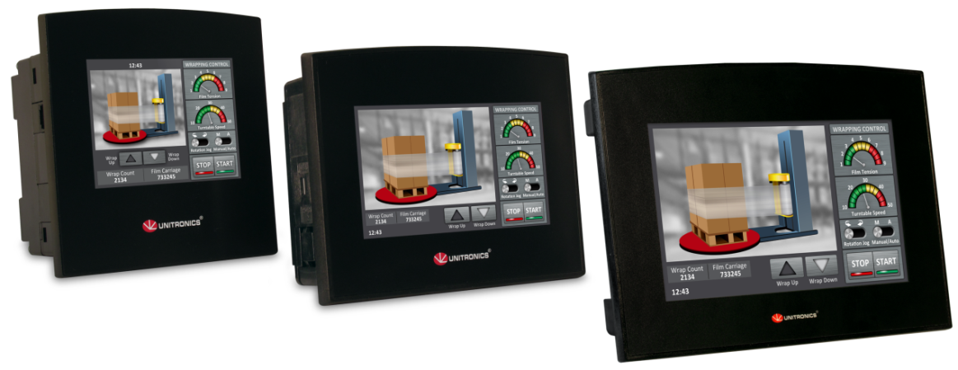
All-in-one, palm-size PLC with HMI and onboard I/Os
The flat fascia and IP66/IP65/NEMA4X rating makes Samba an excellent fit for the food and pharmaceutical industries, anywhere spray or wipe down requirements apply. All Samba units come supplied with a programming port (USB for 4.3'' and 7 ", RS232 for 3.5''). Additional ports can be added: RS485 or Ethernet, and CANbus port. Samba supports GPRS/GSM, email and SMS, as well as industrial TCP/IP protocols, MODBUS, DF1 slave, CANopen, and J1939; it can also be adapted to any 3rd-party protocol.
Samba™ uses Unitronics’ free VisiLogic software. VisiLogic provides a single, simple environment for hardware and communications configuration, Ladder application development, and HMI design, including a free library of industrial images. Free utilities include remote PC access and data export. Unitronics offers unlimited technical support for all of their products and supports an active user forum.
Samba offers all the functionality system integrators need for small applications, reduces space and wiring requirements, and eliminates the need to set up Panel-PLC communication—resulting in an excellent price-performance ratio.
###
About Unitronics
Unitronics (R”G) Ltd. is an Israeli company with international presence that has been producing PLCs, automation software and accessory devices since 1989.
The very first all-in-one controller—HMI+ PLC + onboard I/Os—was released by Unitronics nearly 25 years ago. An early pioneer of this market, Unitronics continues to be a global trendsetter in developing and manufacturing all-in-one controllers with a price/performance profile that boosts competitive advantage.
Unitronics’ OPLC controllers combine full-function PLCs and HMI operating panels into single, compact units. These HMI + PLC devices are programmed in a single, user-friendly environment. Our clients save I/O points, wiring, space, and programming time; elements that translate directly into cost-efficiency.
Unitronics supports a global network of distributors, as well as a US subsidiary.
For more information, visit our website: www.unitronics.com, contact Unitronics at Tel.: +972-3-39778888, Fax: +972-3-39778877, or email: export@unitronics.com.

