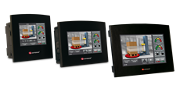

Press Release For Immediate Release

Samba™ RA22—the New Configuration
Jazz—High-speed at Low Cost: HSC, PWM
by Unitronics
The Best in Price/Performance
March 2016
Unitronics’ new All-in-One HMI + PLC controller models will make your customers happy—while you benefit from a great price/performance ratio
Award-winning Samba, the PLC + HMI with a beautiful color screen, has now been released with a new on-board I/O configuration. Models SM35-J-RA22 & SM43-J-RA22 both offer:
- 12 digital inputs
2 may be configured as analog, 2as PT100/TC, and 1 as HSC/shaft-encoder input
- 2 analog, inputs
- 8 relay outputs
- 2 analog outputs
Jazz, the perfect, low-cost solution for simple projects that require a PLC and a text-only HMI panel, now offers two new models that bring you high-speed on a budget. As members of the Jazz 2 family, both support the Ethernet Add-on module, enabling you to implement both MODBUS/TCP and PC-PLC communications.
These Jazz 20 models offer.
- JZ20-J-T20HS
6 digital inputs including 3 high-speed inputs (HSC/shaft-encoder), 2 analog/digital inputs, 2 analog inputs, 10 transistor outputs including 3 high speed outputs (2 high speed outputs @ 32kHz or 3 high speed outputs @ 3kHz)
These outputs support PWM via hardware configuration, no Special Functions required.
- JZ20-J-R16HS
6 digital inputs including 3 high-speed inputs (HSC/shaft-encoder), 2 analog/digital inputs, 2 analog inputs, 6 relay outputs
Produced by Unitronics, a global developer and manufacturer of PLC + HMI controllers, all products are backed by Unitronics standard policy of customer care, including software and utilities, membership in an active, moderated technical support forum, and personalized technical support—all at no additional cost. This combines with all the functionality system integrators need for small applications, reduces space and wiring requirements, and eliminates the need to set up Panel-PLC communication —everything you need to benefit from the best price-performance ratio in the industry.
About Samba
Samba fills a growing niche—OEMs on a tight budget who need compact controllers for simple machine control, but still want the competitive advantage of an elegant, color-touch HMI panel. Awarded the prestigious Engineer’s Choice Award by Control engineering, Samba is available with screen dimensions of 3.5”, 4.3”, and 7”.
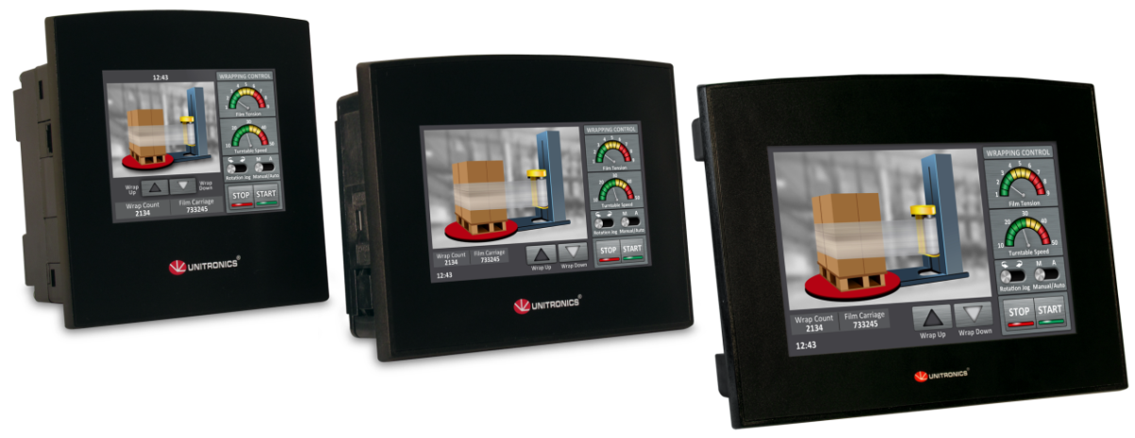
All-in-One Samba, PLC with HMI and onboard I/Os
All models offer a beautiful HMI 16-bit touchscreen that enables data entry and display of variable data on user-designed screens, as well as color Trend graphs, and built-in Alarm screens. The integrated PLC offers a broad range of features including 2 auto-tuned PID loops, time-based RTC control, data logging, recipes and more.
Onboard I/Os offer digital, analog, and high-speed functionality.
The flat fascia and IP66/IP65/NEMA4X rating makes Samba an excellent fit for the food and pharmaceutical industries, anywhere spray or wipe down requirements apply. All Samba units come supplied with a programming port (USB for 4.3'' and 7 ", RS232 for 3.5''). Additional ports can be added: RS485 or Ethernet, and CANbus port. Samba supports GPRS/GSM, email and SMS, as well as industrial TCP/IP protocols, MODBUS, DF1 slave, CANopen, and J1939; it can also be adapted to any 3rd-party protocol.
Samba™ uses Unitronics’ free VisiLogic software. Visilogic provides a single, simple environment for hardware and communications configuration, Ladder application development, and HMI design, including a free library of industrial images. Free utilities include remote PC access and data export. Unitronics offers unlimited technical support for all of their products and supports an active user forum.

About Jazz 20
Jazz®--the PLC + HMI that replaces a simple "Smart Relay" with a real PLC—for the same low price.
Jazz® series controllers are full-function PLC + text HMI with onboard I/Os—available in configurations including digital, analog, temperature, and high-speed I/Os. Specifically designed to control small machines, and to perform simple-to-medium automation tasks, Jazz enables you to use a low-budget unit without compromising on features and technology.
Jazz® offers the flexibility of Ladder programming plus communication options such as GSM/SMS, Remote Access, and MODBUS networking. The HMI application enables you to design up to 60 text screens, using up to 64 HMI variables for the display of time, date, and real-time system data. Programming is as easy as it gets—build Ladder Logic control applications using click-and-drop elements…and create your HMI application in the same U90 Ladder software environment, included at no extra cost.

###
About Unitronics
Unitronics (R”G) Ltd. is an Israeli company with international presence that has been producing PLCs, automation software and accessory devices since 1989.
The very first all-in-one controller—HMI+ PLC + onboard I/Os—was released by Unitronics nearly 25 years ago. An early pioneer of this market, Unitronics continues to be a global trendsetter in developing and manufacturing all-in-one controllers with a price/performance profile that boosts competitive advantage.
Unitronics’ All-in-One controllers combine full-function PLCs and HMI operating panels into single, compact units. These HMI + PLC devices are programmed in a single, user-friendly environment. Our clients save I/O points, wiring, space, and programming time; elements that translate directly into cost-efficiency.
Unitronics supports a global network of distributors, as well as a US subsidiary.
For more information, visit our website: www.unitronics.com, contact Unitronics at Tel.: +972-3-39778888, Fax: +972-3-39778877, or email: export@unitronics.com.

