Unitronics introduces new lower cost 7’’ UniStream™ panel
Unitronics, the industry leader in the development and manufacture of integrated PLC + HMI controllers, recently launched the fourth model of the UniStream™ product line – lower cost UniStream 7" panel. This model was designed specifically to improve the price competitiveness of the current UniStream 7" panel in the market. The differences between the current 7" panel and new model are minor, and the unit is completely backwards compatible with the current unit.
The UniStream™ line, combines with UniLogic™ programming environment, offers one of the best and most advanced solutions in the market today. With the new pricing, it is now also one of the most cost effective ones.
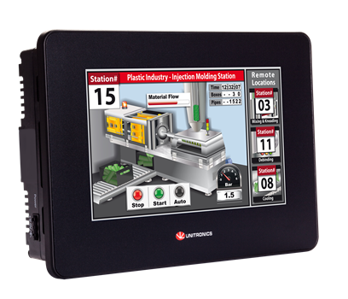
The UniStream line is the result of over 20 years of experience with PLC development, combined with the strongest new trends in automation. Unistream™ incorporates a powerful dual CPU, sleek HMI touch panels, and a variety of I/O options. The user can create an all-in-one controller by snapping on a CPU and I/O modules to the HMI of their choice. The award-winning UniStream™ gives OEMs and systems integrators a competitive edge, enabling them to customize their PLC, cut costs and shorten their programming time by over 50%.
UniStream™ offers options for RS485, CANopen, UniCAN, and both serial and Ethernet MODBUS communications. Unistream™ supports Ethernet/IP™ and can be adapted to other third-party protocols; the USB and serial ports support external devices such as modems, printers, barcode readers and more.
UniLogic™, the software for Unitronics’ UniStream line enables users to code Ladder, design HMI screens and Web pages, configure hardware, set up and implement communications, and more in a single programming environment. UniLogic’s efficient features can slash your development time by over 50%.
Unitronics is a pioneer in the manufacturing and design of PLCs with integrated HMI and on-board I/Os - rugged PLC product lines that meet a diverse range of requirements. Program your entire application in a single, intuitive software environment, and benefit from best-of-breed technical support, both provided at no extra cost.
###

About Unitronics:
Unitronics designs, manufactures, and markets quality PLCs for the global market. Easy -to-use, efficient, and affordable, our products have been automating processes, systems, and stand-alone applications since 1989. We maintain more than 160 distributors in over 55 countries around the globe, enabling our customers to purchase our products with local marketing support.
Unitronics' field-proven PLCs automate hundreds of thousands of installations in diverse fields: petrochemical, automotive, food processing, plastic & textile, energy & environment, water & waste water management—anywhere automated processes are required.
Our clients include: Coca-Cola, General Motors, Michelin, Tupperware, Intel, Bayer, Colgate-Palmolive, Land Instruments, Mercedes, Agfa, Tyson Foods, Pirelli, Fiat, Samsonite
Click here for Unitronics success stories
For more information, visit our website: www.unitronics.com, contact Unitronics at Tel.: +972-3-39778888, Fax: +972-3-39778877, or email: export@unitronics.com

